Mrs. Whitman’s and Mr. Everhart’s GOALS for students:
- The student will be able to successfully design, perform, analyze, evaluate, and extend scientific experiments given minimal supplies and minimal guidelines.
- The student will be able to effectively read graphs and charts, create graphs and charts, infer based on graphs and charts, and support his/her conclusions and thoughts using data from graphs and charts.
- Using web design, coding, and essays, the student will be able to explain and support scientific phenomena.
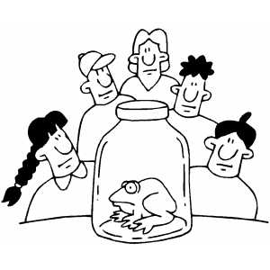
As Mrs. Whitman’s or Mr. Everhart’s student, I agree to work towards the above goals as well as the following goals:
Student Goals:
1.___________________________________________________________________________________________________________________________________________________________________________________________________________________________________________________.
2.___________________________________________________________________________________________________________________________________________________________________________________________________________________________________________________.
3.___________________________________________________________________________________________________________________________________________________________________________________________________________________________________________________.

_______________________________ ________________
Student Signature Date

